Physics Higher Level 2024

1.
1. A student carried out a laboratory experiment to investigate the relationship between the acceleration a of a body and the force F applied to it. During the experiment the student recorded values for the force and measured the associated acceleration.
F (N) | 0.2 | 0.3 | 0.4 | 0.5 | 0.6 | 0.7
a (m s⁻²) | 0.280 | 0.422 | 0.554 | 0.702 | 0.837 | 0.982
The following data were recorded.

- Draw a labelled diagram of how the apparatus was arranged in this experiment.
- Describe how the student determined the acceleration of the body.
- Draw a suitable graph to show the relationship between F and a.
- Explain how your graph verifies the relationship between F and a.
- Use your graph to calculate the mass that had been accelerated.
- Sketch the graph that a student would get if they did not account for the presence of a constant frictional force of less than 0.2 N.

2.
In an experiment to measure the focal length f of a converging lens, a student first found an approximate value for the focal length. Then the student set up the apparatus and recorded the image distance v for different values of the object distance u.
u (cm) | 20.0 | 30.0 | 40.0 | 50.0
v (cm) | 78.7 | 35.2 | 26.9 | 23.4
The following data were recorded.

- Describe how the student found an approximate value for the focal length.
- Draw a labelled diagram of the apparatus and clearly identify the distances u and v.
- Describe, with reference to your diagram, how the values for v were determined and measured.
- Calculate the focal length of the lens using all of the data in the table.
- The student also completed an experiment to measure the focal length of a concave mirror.
Why does the arrangement of the apparatus differ in this experiment?

3.
A student carried out an experiment to measure the specific latent heat of fusion of ice.
Mass of calorimeter |  | 83.2 g
Mass of calorimeter + water | before adding ice | 132.9 g
Mass of calorimeter + water | after adding ice | 138.5 g
Temperature of water | before adding ice | 26.8 °C
Temperature of water | after adding ice | 17.4 °C
The following data were recorded.

- Draw a labelled diagram of the apparatus used in this experiment.
- Ice for the experiment was taken from the freezer.
The student prepared the ice to ensure that only ice at 0 °C was added to the warm water.
  - State two steps the student took to prepare the ice taken from the freezer.
  - Describe the importance of each step.
- Use the data in the table to calculate the energy lost by the calorimeter after the ice was added.
- Hence, or otherwise, calculate the specific latent heat of fusion of ice.
- State two properties of a thermometer that would help improve the accuracy of the experiment.
specific heat capacity of water = 4180 J kg^{–1} K^{–1}; specific heat capacity of copper = 390 J kg^{–1} K^{–1}

4.
A student investigated how the fundamental frequency f of a stretched string of length 70 cm varied with its tension T.
During the experiment, the length of the string was kept constant, and the student varied the tension.
f (Hz) | 256 | 320 | 341 | 426.5 | 480 | 512
T (N) | 29 | 44 | 51 | 79 | 100 | 115
The following data were recorded.

- Draw a labelled diagram of how the apparatus was arranged in this experiment.
- How did the student determine that resonance had occurred?
- Describe how the student determined
  - the frequency f,
  - the tension T.
- Draw a suitable graph to show the relationship between f and T.
- State the relationship between f and T.
- Use your graph to determine the mass per unit length of the string used in this experiment.

5.
In an experiment to investigate the relationship between current I and potential difference V for a length of copper wire the following data were recorded.
V (V) | 1.0 | 2.0 | 3.0 | 4.0 | 5.0 | 6.0
I (A) | 0.14 | 0.26 | 0.43 | 0.58 | 0.70 | 0.84

- Draw a circuit diagram for this experiment.
- Draw a suitable graph to show the relationship between I and V.
- Use your graph to calculate the resistance R of the copper wire. (26)

The student used their results to calculate the resistivity of the copper wire.
The following additional data were recorded:
length of wire = 65 cm
diameter of wire = 0.32 mm

- Describe how the student determined both the length and the diameter of the copper wire.
- Calculate the resistivity of the copper wire.

6.
Answer any eight of the following parts, (a), (b), (c), etc.

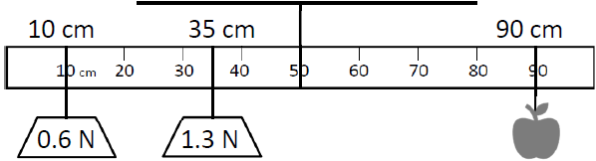
    - A meter stick is suspended from its centre of gravity as shown in the diagram.
The meter stick is in equilibrium.
Calculate the mass of the apple.

    - Explain what is meant by a geostationary orbit and state a use of a satellite in geostationary orbit.

    - A simple pendulum has a period of 1.24 s. Calculate the length of the pendulum.

    - Conduction and convection are methods of heat transfer.
Distinguish between conduction and convection.
    - Describe an experiment to demonstrate that sound is a wave.
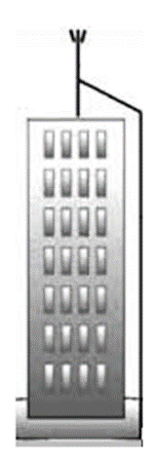
    - Explain what is meant by a stationary wave.
    - Define critical angle.
    - A lightning conductor can be placed on top of a tall building as shown.
Explain how a lightning conductor works.
    - A current of 6 A passes a point in a circuit.
Calculate the number of electrons that pass that point every minute.
    - Calculate the electrostatic force between two protons that are 5.6 x 10^{–15} m apart in a vacuum.
    - Einstein’s photoelectric law is explained by the equation hf = ɸ + ½mv².
Explain what each of the symbols in the equation stands for.
    - Cockcroft and Walton won a Nobel Prize for their experiment that bombarded a lithium nucleus with a proton. State two reasons why their experiment was significant.
or
Draw a diagram to show how a galvanometer can be converted into a voltmeter.

acceleration due to gravity = 9.8 m s^{–2}

7.
The hammer throw is an athletics event where athletes rotate a metal ball, attached to a wire, in a circle before releasing it.
- Derive the formula to show the relationship between the radius, velocity and angular velocity of an object moving with uniform circular motion.
- Explain what is meant by centripetal force.
- Draw a force diagram to show the forces acting on the ball just before it is released.

An athlete rotates a ball of mass 4 kg in a circle of radius 1.25 m.
The ball is moving with an angular velocity of 21.6 rad s^{–1} just before it is released.
- Calculate the centripetal force acting on the ball just before it is released.
- Calculate the magnitude of the velocity of the ball just as it is released.

The velocity of the ball as it is released is at an angle of 36° above the horizontal.
The ball is released at a height of 1.26 m above the ground and lands 3.79 s later.
- With the aid of a labelled diagram, resolve the velocity of the ball into its horizontal and vertical components.
- Ignoring air resistance,
  - calculate the maximum height above the ground reached by the ball,
  - calculate the horizontal distance travelled by the ball in 3.79 s.
- How would air resistance affect the path of the ball?

acceleration due to gravity = 9.8 m s^{–2}

8.
A moving-coil loudspeaker is based on the principle that a current-carrying conductor in a magnetic field experiences a force.
- State two quantities that affect the magnitude of the force on a current-carrying conductor in a magnetic field.
- Describe a laboratory experiment to demonstrate that a current-carrying conductor in a magnetic field experiences a force.
- Draw a diagram of the magnetic field produced by a current flowing in a long straight wire.
- A wire of length 65 cm carrying a current of 3 A experiences a force of 7 mN when placed in a magnetic field. Calculate the magnetic flux density of the field when the current is flowing at right angles to the field.
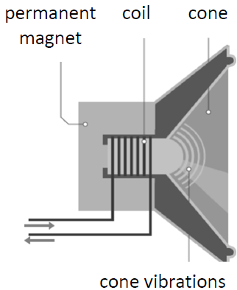
A loudspeaker has three main components as shown in the diagram: the magnet, the coil and the cone.
The cone vibrations cause pressure variations in the air that produce sound waves of frequency 512 Hz.
- What type of wave is sound?
- Calculate the wavelength of the sound wave produced.

- The amplitude of the vibrations of the cone determines the amplitude of the sound wave produced.
What musical characteristic is determined by the amplitude of the wave?

A loudspeaker has a power of 80 mW.
- Calculate the sound intensity for a person standing 7 m from the loudspeaker.
- This sound intensity is halved for the person when they stand a distance d from the loudspeaker.
Calculate d.
- After this, the speaker of power 80 mW is replaced by a speaker of power 20 mW.
Calculate the decrease in sound intensity level.

speed of sound = 340 m s^{–1}

9.
(a)
The resistance of a semiconductor depends on multiple factors, one of which is temperature.
A thermistor is a temperature-dependent semiconductor.
- What is a semiconductor?
- Sketch a graph to show the relationship between temperature and resistance for a thermistor.
- Explain the shape of the graph in terms of the charge carriers in semiconductors.
- Distinguish between intrinsic and extrinsic conduction in semiconductors.

(b)
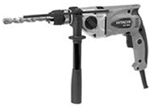
A current of 5 A flows in an electric drill when it is connected to the mains supply. Some of the input energy is dissipated as heat.
- State Joule’s law.
- The drill has an electrical resistance of 22 Ω and it runs for 30 s.
Calculate the heat energy produced by the drill.
- Calculate the input power supplied to the drill by the 230 V mains supply.
- Calculate the percentage efficiency of the drill.
(c)
The mains supply is provided to homes at 230 V.
However, electrical energy is transmitted using high voltages of approximately 300 kV in power lines.
- Explain why high voltages are used in the transmission of electrical energy.
- Name a device that is used to reduce the voltage from 300 kV to 230 V.

10.
(a)
Food irradiation is used to delay spoilage and prevent illness caused by microorganisms.
It is the process of exposing food and food packaging to ionising radiation, such as X–rays and gamma rays.
- Explain what is meant by ionisation.
- Describe a laboratory experiment to demonstrate the ionising ability of nuclear radiation.

X–rays used for food irradiation have a minimum wavelength of 1.02 × 10^{–11} m.
- Explain how X–rays are produced.
- Calculate the maximum energy of the X–rays used for food irradiation.

Cobalt–60 is commonly used to produce gamma rays for food irradiation.
Cobalt–60 emits gamma rays with an average energy of 1.25 MeV.
- Explain what is meant by gamma rays.
- How many times bigger is the average energy of the gamma rays than the maximum energy of the X–rays?
(b)
Cobalt–60 is a radioactive isotope.
It is produced artificially in nuclear fission reactors.
- What are isotopes?
- Explain what is meant by nuclear fission.
- Distinguish between the role of the moderator and the control rods in a nuclear fission reactor.

11.

A device that is designed to store energy when it holds a charge is called a capacitor.
- Define capacitance.
- Describe an experiment to demonstrate that capacitance depends on the common area of the plates of a parallel plate capacitor.
- Sketch a suitable graph to show the relationship between capacitance C and the common area A between the plates of a parallel plate capacitor.

A parallel-plate capacitor with metal plates of area 0.0225 m² are placed 8 mm apart in a vacuum.
A voltage of 3 kV is applied across the plates.
- Calculate the maximum potential energy stored in the capacitor.
- A material with a relative permittivity of 2 is then inserted to completely fill the space between the capacitor plates. What is the effect on the maximum potential energy stored by the capacitor?

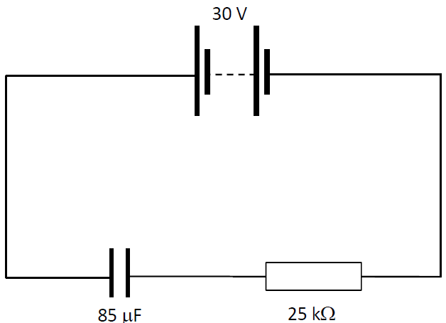
Capacitors and resistors can be combined to create timing circuits such as those used to create the flash on a camera.
The circuit diagram shows a resistor and a capacitator connected in series with a 30 V power supply.
The current flowing in the circuit at a given instant is 0.3 mA.

- Calculate the potential difference across the resistor at this instant.
- Calculate the charge held by the capacitor at this instant.
- Draw a diagram to show the electric field between the plates of the charged capacitor.

12. Answer either part (a) or part (b).

(a)
All matter and energy in the universe must abide by one or more of the four fundamental forces of nature.
- Which force is the weakest of the four forces?
- Which force is responsible for binding the nucleus?
- State the two fundamental forces of nature that are based on inverse square laws.
- Name the fundamental force that allows for beta-decay.

When it was observed that momentum did not appear to be conserved during beta-decay, Wolfgang Pauli proposed that an additional particle must be emitted to carry away the missing momentum and energy.
Pauli wrote, “I have done something very bad today by proposing a particle that cannot be detected; it is something no theorist should ever do”.
- Identify the particle that Pauli proposed.
- Explain why it is difficult to detect this particle.
- Write an equation to represent the decay of a neutron ($n_{0}^{1}$) by beta-decay.
- Calculate the energy released during this beta-decay.

Neutrons involved in beta-decay are classified as baryons, while electrons and positrons are classified as leptons.
- State a difference between baryons and leptons.
- Neutrons are neutral baryons. Show how the quark model explains this.
- Pair annihilation occurs when an electron and a positron meet. Write an equation that represents this process.

(b)
The mains electricity supply in Ireland is a.c. and operates at a frequency of 50 Hz.
However, many electrical appliances in the home require d.c. to operate.
- Distinguish between a.c. and d.c..
- Draw a voltage–time graph for an a.c. supply and a d.c. supply.
- Draw a circuit diagram of a half-wave rectifier that can be used to convert a.c. to d.c..
- Sketch the graph of the output voltage of this circuit. (27)

A voltage inverter can be used to convert d.c. to a.c.. A transistor can be used to build a NOT gate in a voltage inverter circuit.
- Draw a labelled diagram of the structure of a bi-polar transistor.
- Draw a truth table for a NOT gate.

The induction coil was invented by Dr Nicolas Callan in 1836.
- Draw a labelled diagram showing the main components of an induction coil.
- Describe how an induction coil can be used to produce a large d.c. voltage.

13. Read the following passage and answer the accompanying questions.
John Tyndall ranks as one of Ireland’s most successful scientists and educators. He reached the pinnacle of 19th century science and counted amongst his friends and collaborators many of the best known scientists of that century. Tyndall’s scientific interests spanned heat, sound, light and environmental phenomena.
Amongst his many achievements, perhaps he is best known for the explanation of why the sky is blue – the scattering of light by small particles suspended in the atmosphere. Blue light is scattered more than other colours because it travels at shorter wavelengths. This colour is known as Tyndall Blue.
His major scientific interest was the study of the interaction of light with matter, especially gases.
He studied the absorption of infrared radiation by gases found in the atmosphere. He made the first studies of atmospheric pollution in London.
adapted from: ‘The Ascent of John Tyndall: Victorian Scientist, Mountaineer, and Public Intellectual’ (Roland Jackson) Oxford University Press 2018

- Blue is a primary colour of light.
  - Name the two other primary colours of light.
  - Name the secondary colour produced by these two primary colours.
- A prism can be used to show dispersion of light. What is meant by dispersion of light?
- Name two other items that can cause dispersion of light.
- The refractive index of a medium varies for different wavelengths of light. Therefore, different colours travel at different speeds and are turned through different angles.
  - Explain what is meant by refractive index.
  - The refractive index of a block of glass for red light is 1.51 and for violet light is 1.53.
Calculate the difference between the speed of the red light and the speed of the violet light as they travel through the block of glass.
- Tyndall also did work in the field of spectroscopy. A photon of blue light, of frequency 6.54 × 10¹⁴ Hz, is produced in a line emission spectrum. This occurs when an electron falls from an energy level 6 x 10^{–19} J to a lower energy level.
  - Calculate the energy of the lower energy level.
  - Distinguish between a line emission spectrum and a continuous emission spectrum.
  - State one use of spectroscopy as a tool in science.
- Infrared radiation is part of the electromagnetic spectrum. List any four other parts of the electromagnetic spectrum in order of increasing frequency.

14. Answer any two of the following parts, (a), (b), (c), (d).

(a)
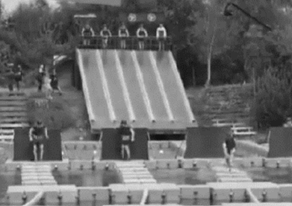
Ireland’s Fittest Family is a competition where families compete across a range of different fitness challenges. These challenges exemplify many physics principles in action.
- State the law of conservation of energy.

A man is competing in a race where participants are required to slide from a raised horizontal platform down a 2.4 m long slide. The slide is at an angle of 32° to the horizontal from the platform.
The end of the slide is a vertical distance of 90 cm above the water.
- Calculate the height of the platform above the surface of the water.
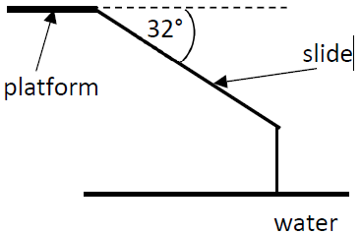
- The man starts from rest. Calculate his velocity as he enters the water.
Assume that there is no friction on the slide.
- Draw a force diagram for the man
- as he slides down the slide,
- when he is floating in the water.
acceleration due to gravity = 9.8 m s^{–2}

(b)
Ra–224 is an unstable nucleus of radium.
- Ra–224 decays by releasing an alpha-particle. Write a nuclear equation for this decay.
- A sample of Ra–224 decays to form Pb–208, an isotope of lead.
  - How many alpha-particles are released?
  - How many beta-particles are released?

Ra–224 has a half-life of 3.6 days.
- Explain what is meant by the term half-life.
- Calculate the total number of alpha-particles emitted per second by a sample of Ra–224 which contains 4.7 × 10¹⁴ atoms.

(c)
- What is meant by thermionic emission?
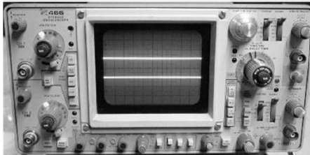
- Draw a labelled diagram of a cathode ray tube.

- A high-speed electron that strikes the screen of an oscilloscope produces the green light that is seen.
Calculate the minimum voltage required across the tube to give an electron a velocity of 2.7 × 10⁷ m s^{–1}.
- How does the photoelectric effect differ from thermionic emission?

(d)
A spectrometer can be used to measure the wavelength of light.
- Draw a labelled diagram of a spectrometer.
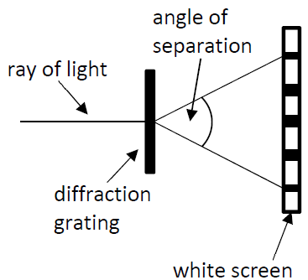
Green light of wavelength 530 nm is passed through a diffraction grating with 400 lines per mm.
- Calculate the angle of separation between the second order images.
- Identify a different colour of light that could be used to produce a greater angle of separation.
- Explain how the number of lines per mm on a diffraction grating affects the angle of separation.

